Activity 1
Command 1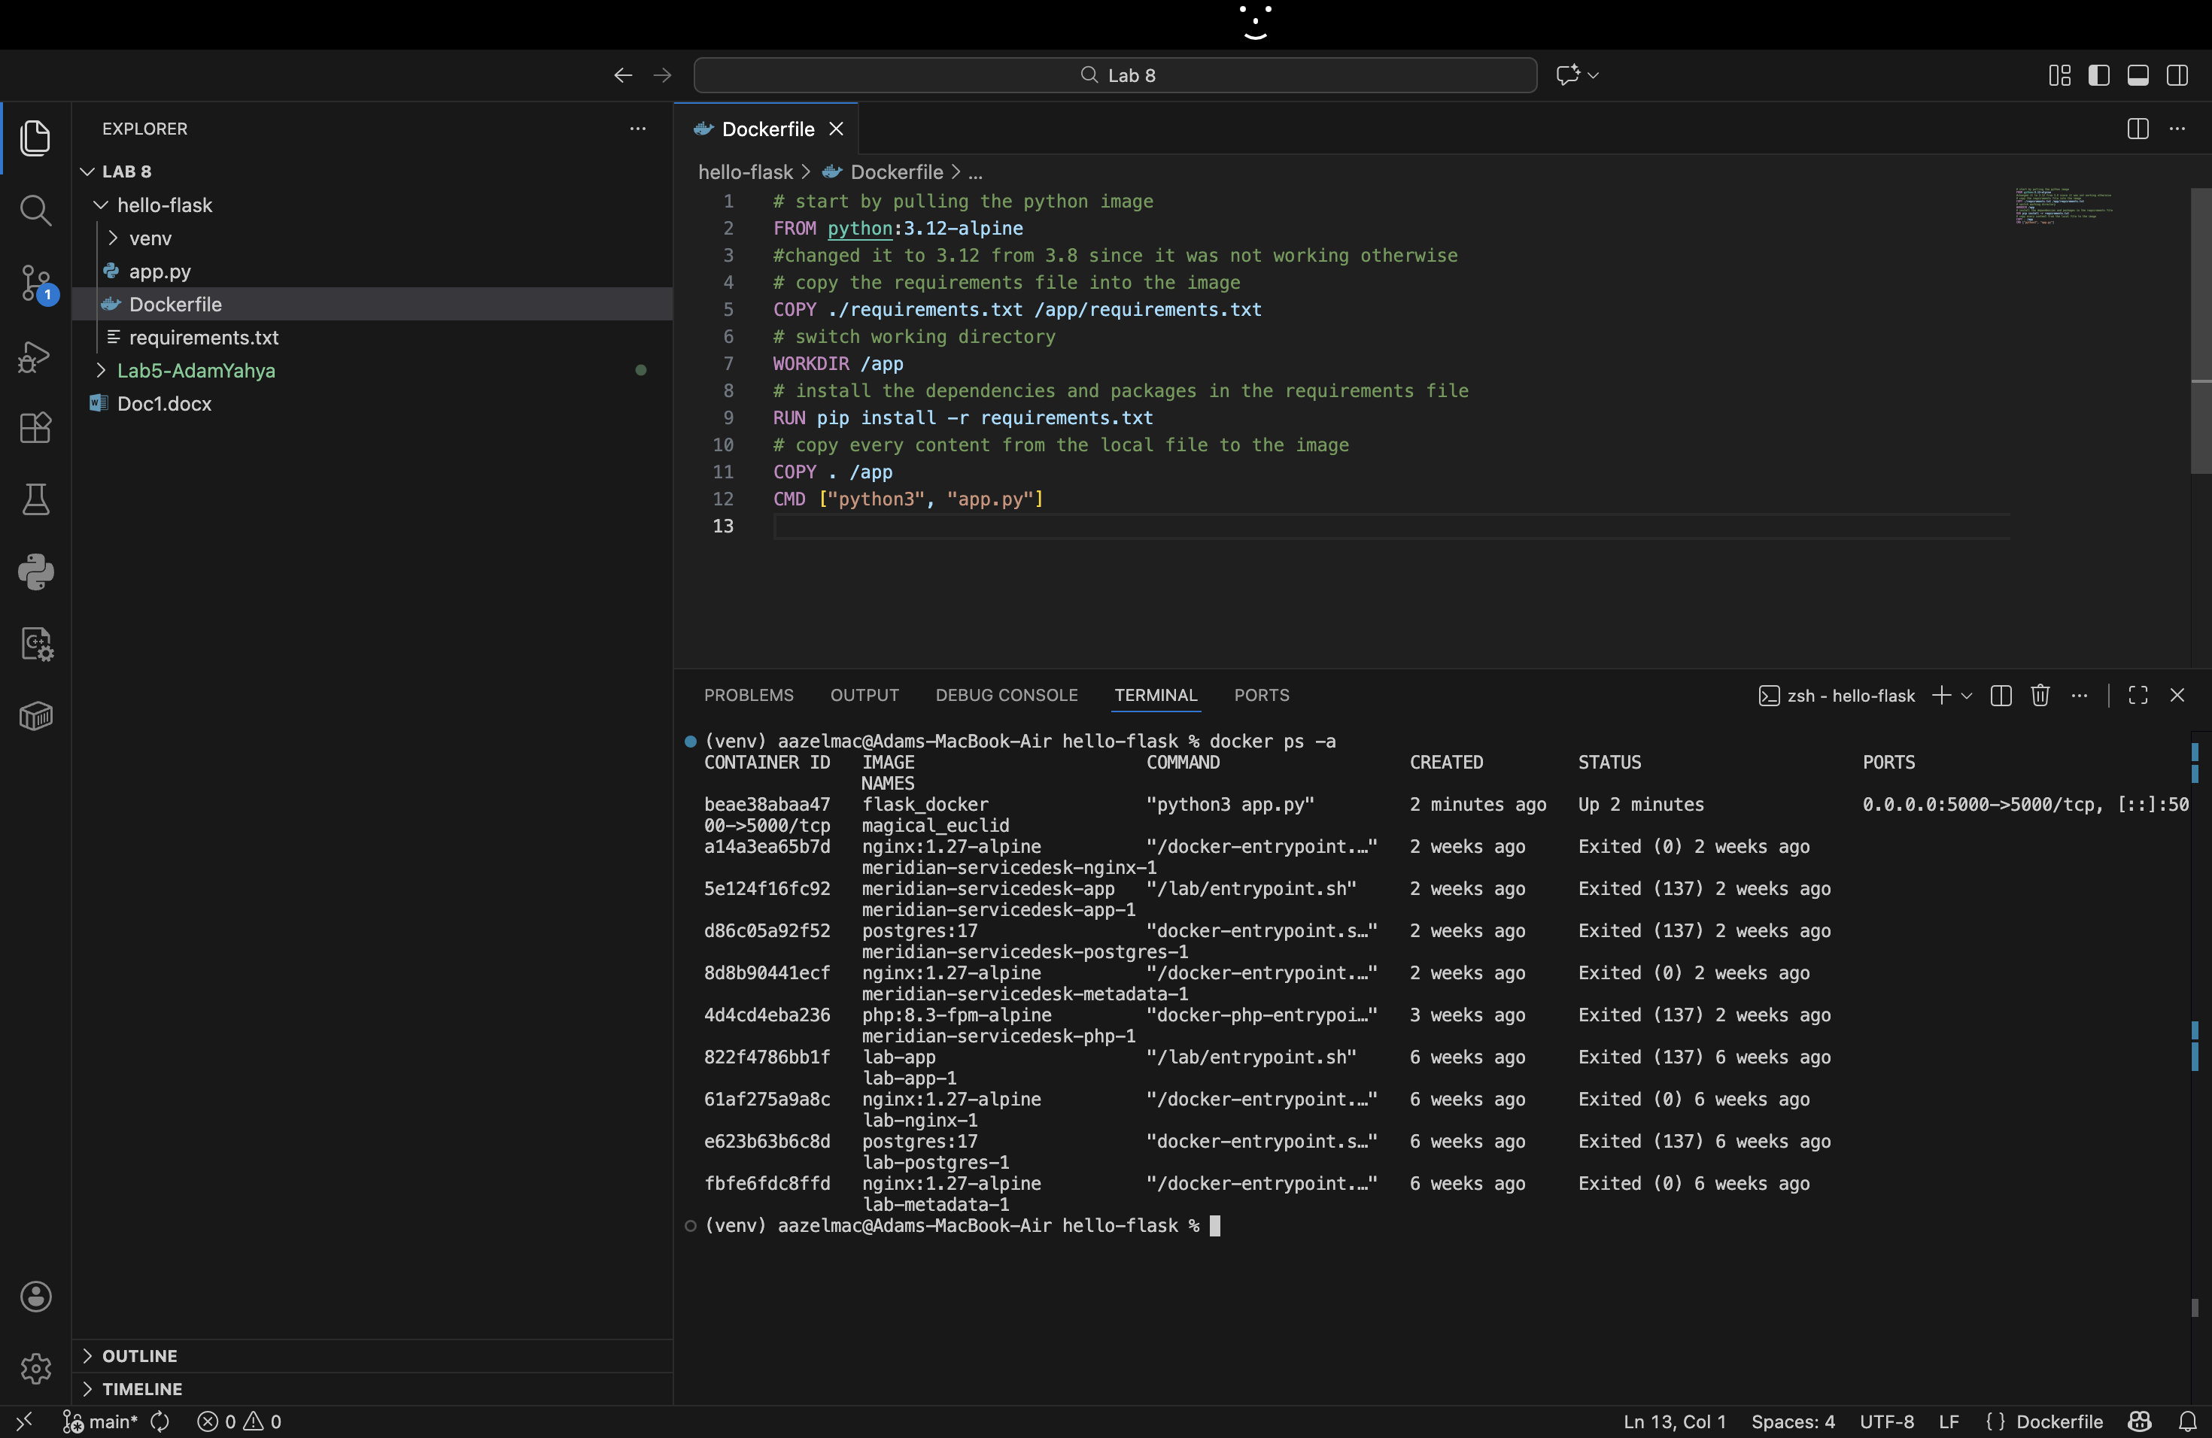
Lists every container on the machine, both running and stopped. Each row shows the container ID, the image it was created from, the command it runs, when it was created, its status, its port mappings and its name. Magical euclid is the one we just created, and the other 2 are ones previously used by me on this laptop.
Command 2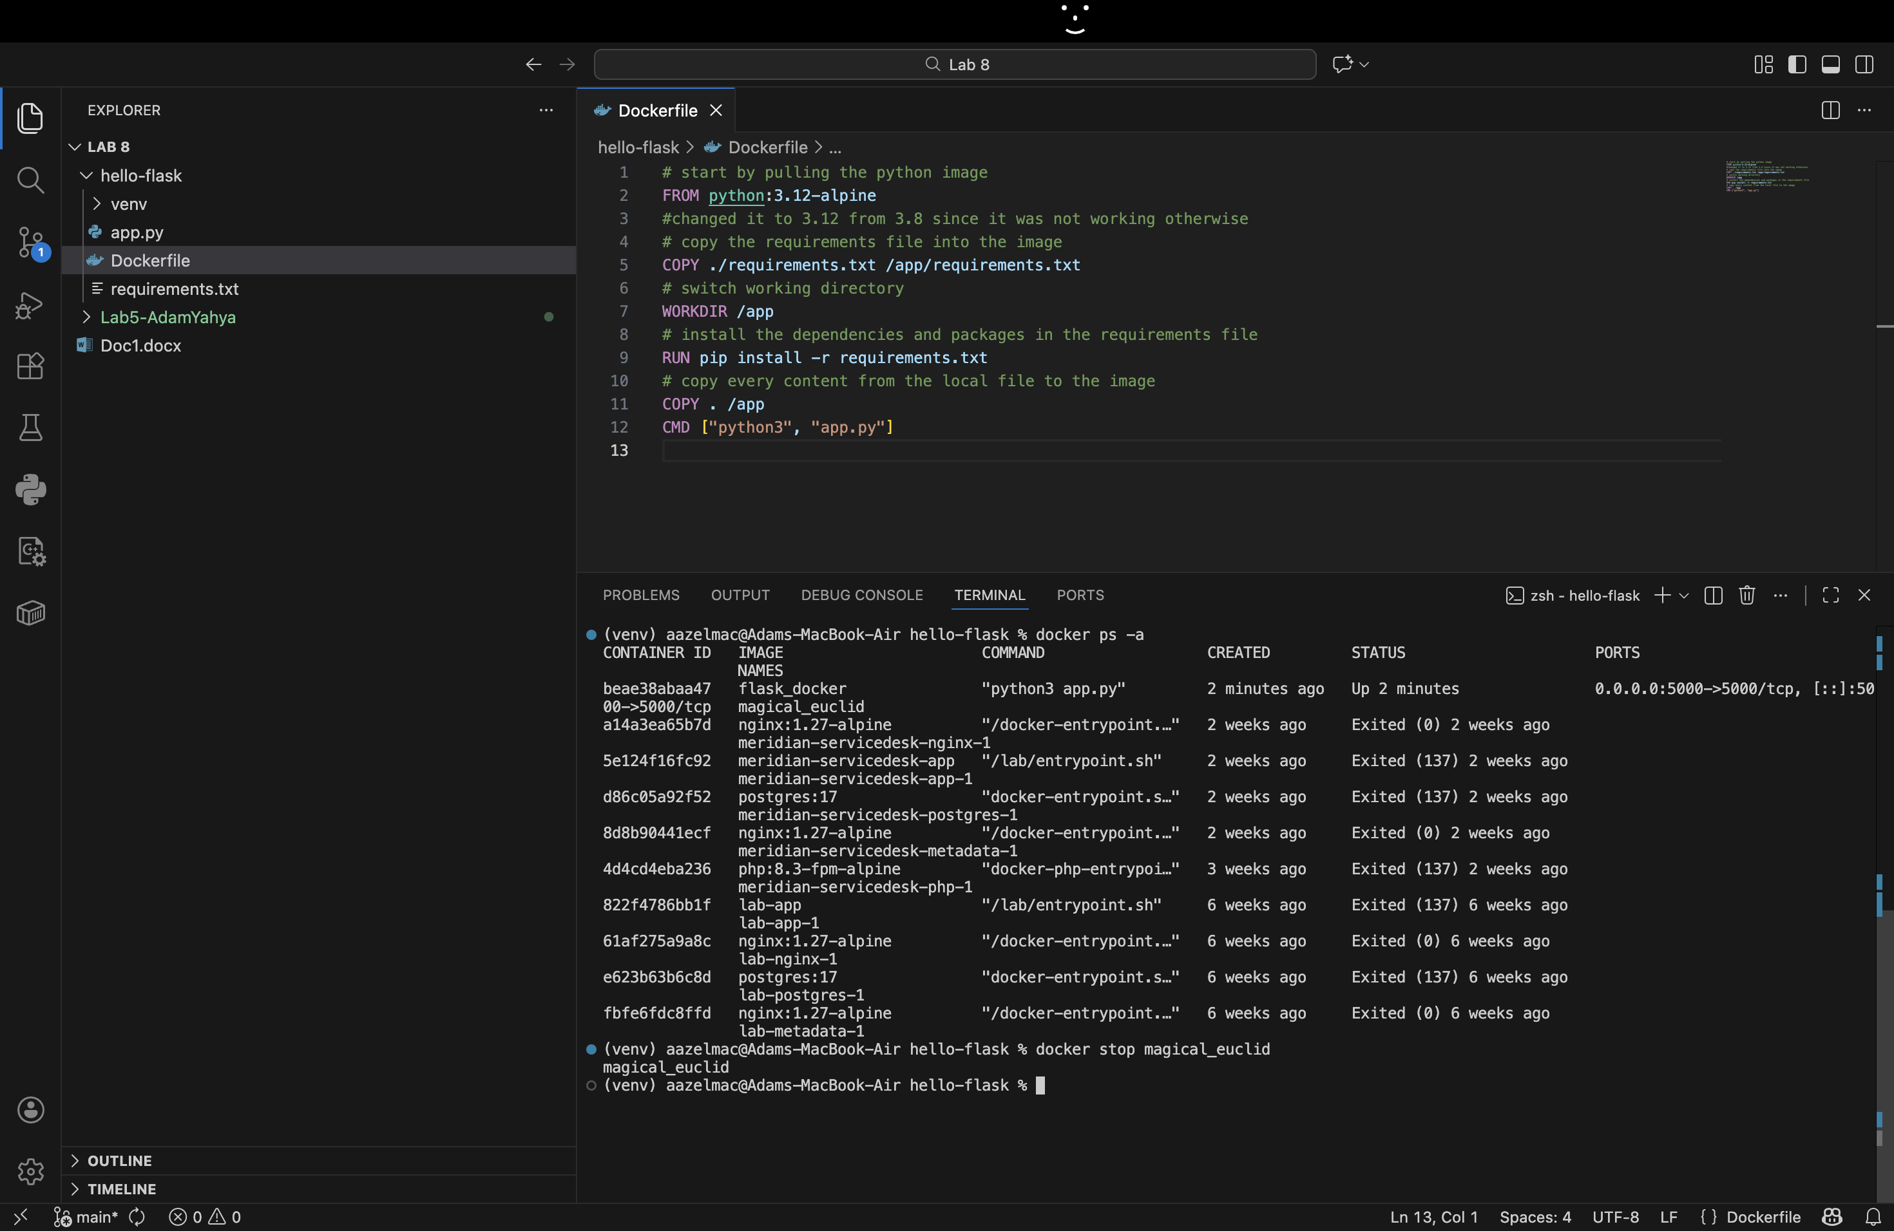
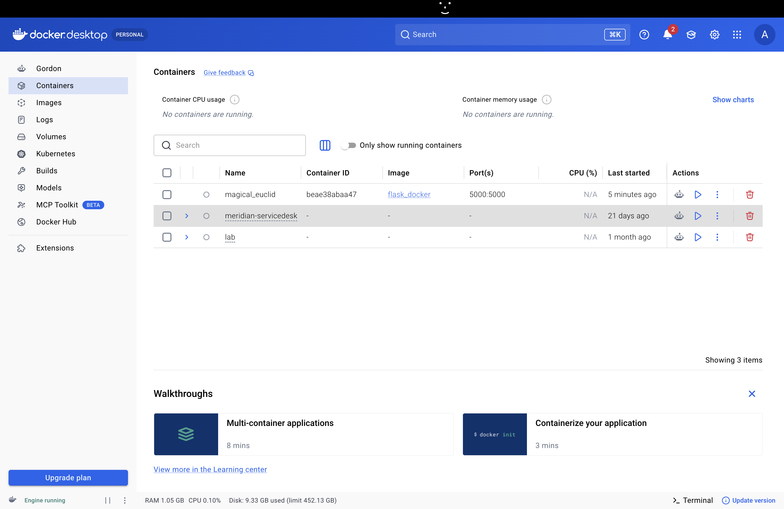
It shuts down a running container. The container is stopped, not deleted, so it still exists and can be started again. Docker prints the container’s name to confirm the stop. Docker Desktop confirms the result; our created container magical_euclid is no longer running.

Command 3
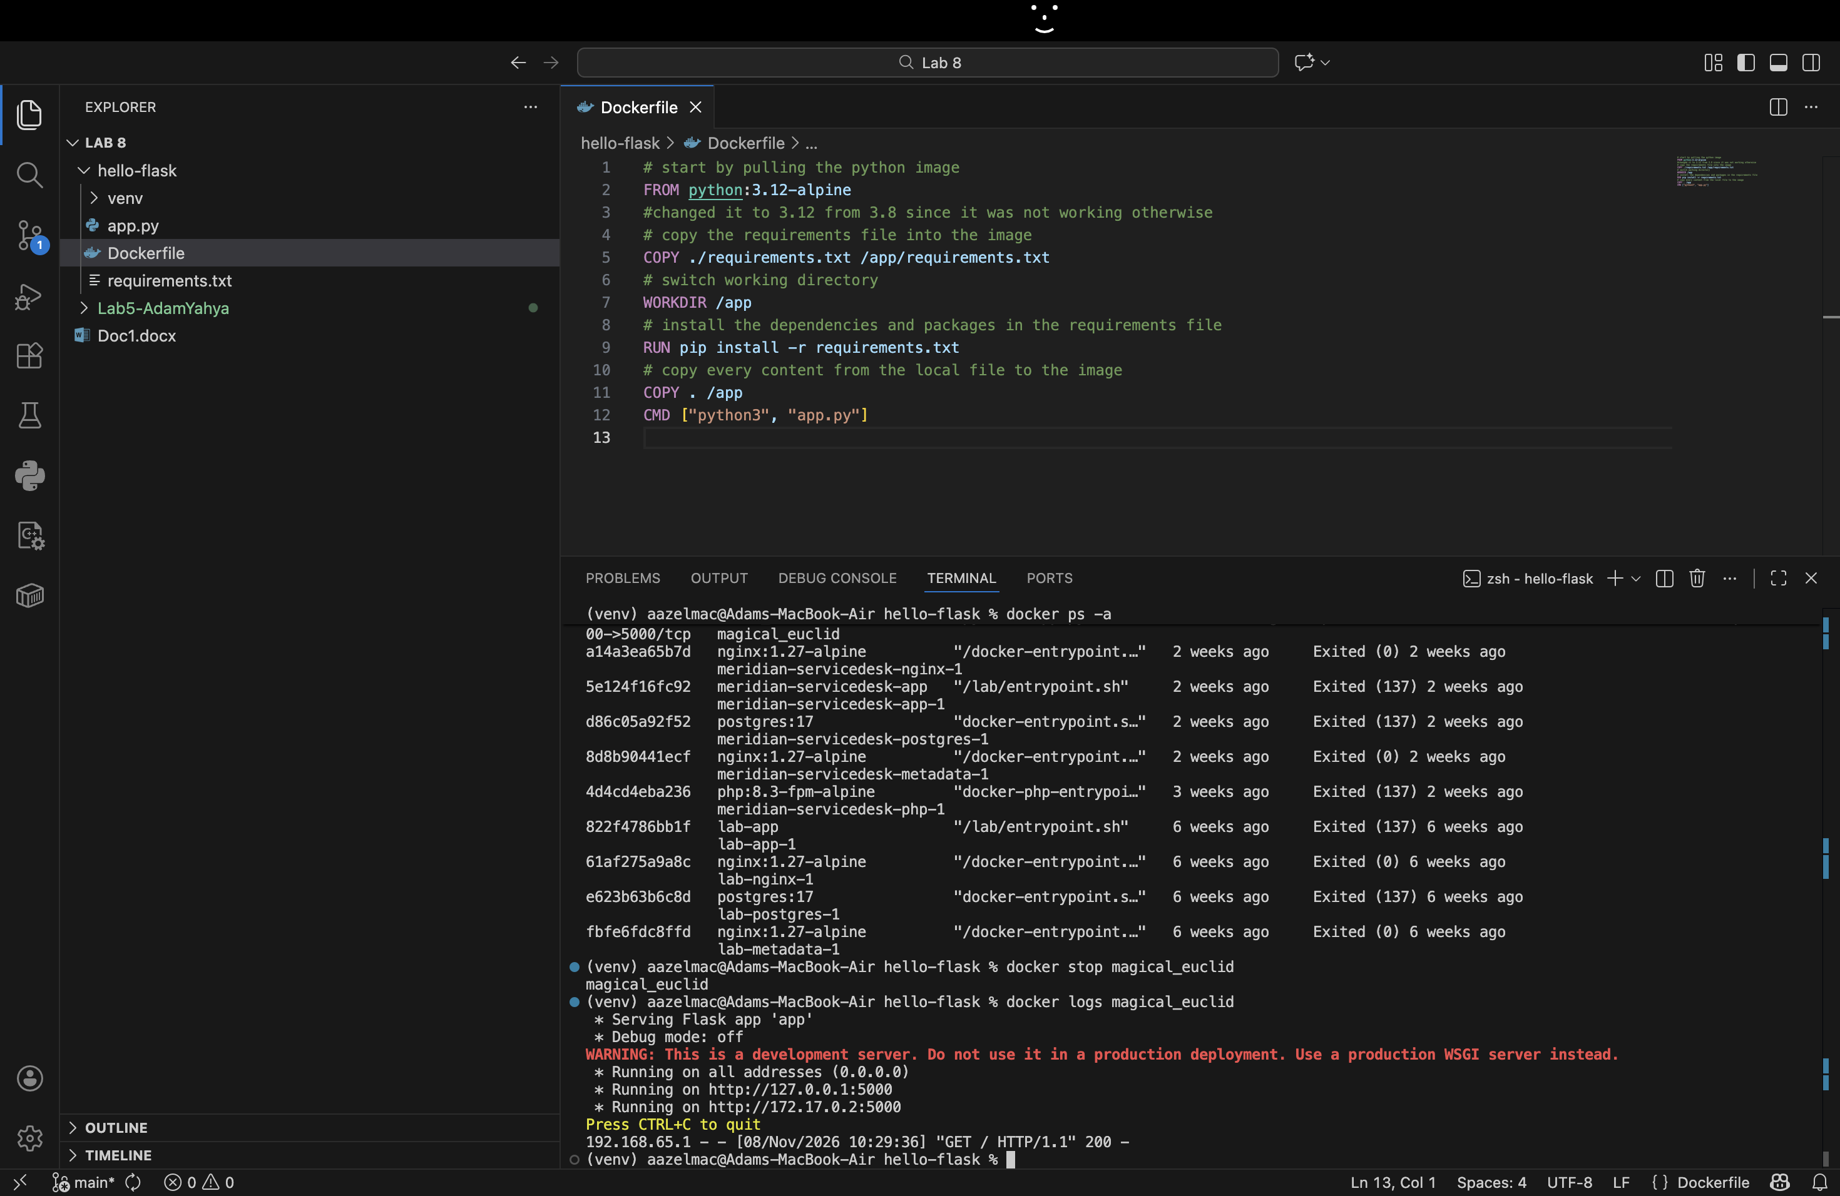
It prints everything the container wrote to its output, even after it has stopped. The last line is a request to the home page that was answered successfully (status 200). That confirms the app inside the container served a request before it was stopped.
Activity 2
We kept the original route because the Lab 5 code already has a get_users() function behind the GET /api/users route, which returns all the users from the database. It already does what the lab asks, so we reused it instead of writing a new route. Both images run the same code, and only the port differs (5000 and 3000).
If a get_users endpoint were required, we would add one short route to database.py that returns just the name of each user, using the existing get_users() function, and then rebuild image 2 so it exposes that endpoint on port 3000.

